**Experiment 26**

**Lab Book:**



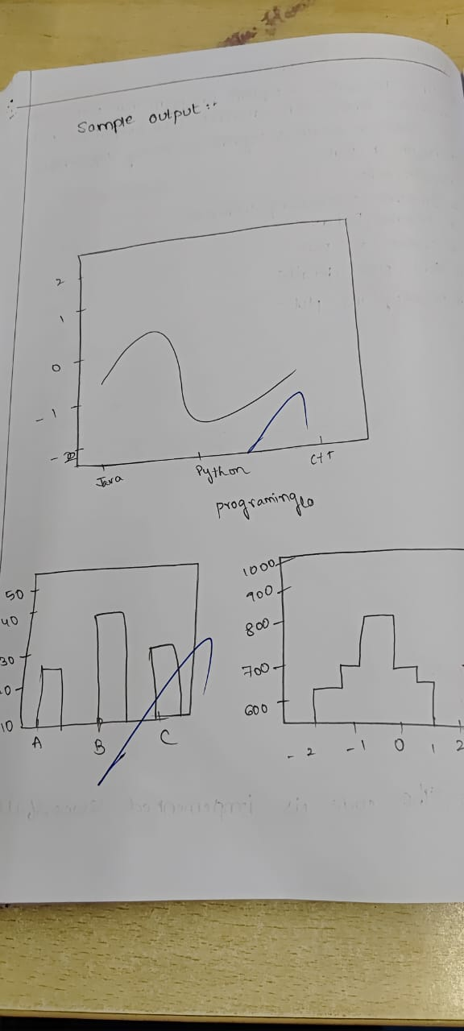

**Code**

import matplotlib.pyplot as plt

a = ['Harini', 'Tejaswini', 'Sowmya', 'Meghana']

b = [95, 75, 90, 65]

# Create a figure with different plots

plt.figure(figsize=(10, 8))

# Line chart

plt.subplot(2, 2, 1)

plt.plot(a,b, marker='o')

plt.title('Line Chart')

# Bar plot

plt.subplot(2, 2, 2)

plt.bar(a,b)

plt.title('Bar Plot')

# Scatter plot

plt.subplot(2, 2, 3)

plt.scatter(a,b)

plt.title('Scatter Plot')

# Pie chart (without percentages)

plt.subplot(2, 2, 4)

plt.pie(b, labels=a)

plt.title('Pie Chart')

plt.tight_layout()

plt.show()

**Sample Output**

